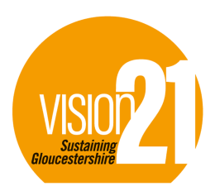
Person Specification: Cheltenham Zero Brand/Communications Manager
Background
Vision 21 is a sustainability charity that was established 1994. Its primary aim is to make Gloucestershire more sustainable and, in particular, to both mitigate and adapt to the effects of Climate Change. As such, we focus our attention on meeting the following four UN Sustainable Development Goals 3,11,12 and 13:
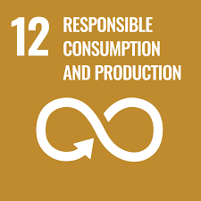
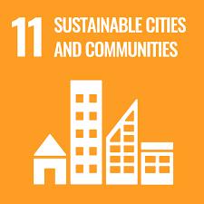

What is CheltenhamZero?
Vision 21 is working in partnership with Cheltenham Borough Council to help achieve a target of a Net Zero Carbon borough by 2030.
“We recognise the climate emergency and acknowledge the unacceptable risks it poses globally and also locally to the future of our environment, our livelihoods, our homes and our town.
By joining CheltenhamZero we commit to tackling the climate emergency head on, doing our part within our organisations and working collaboratively to support the shift to net zero emissions as a town by the year 2030”.
For more information on the CheltenhamZero project: https://cheltenhamzero.org/en-GB/
Person and Salary
This is an exciting opportunity for an experienced communications manager with an interest in the sustainability agenda. Have you experience in driving a brand? Are you passionate about the environment? This could be the role for you.
We are looking for someone who is creative, vibrant and inspiring and can create content to match, reaching new audiences.
It is an excellent opportunity for somebody with a passion for sustainability who wants to help shape the strategy in their community.
We are seeking a part time employee for a two year period. Flexible and hybrid working arrangements will be considered including self employed consultants.
Annual salary £36,556 pro rata at 20 hours per week, equivalent to £19/hr or £19,760/annum. Closing Date 10th July
Job Role
- Develop and expand the CheltenhamZero Brand, working in partnership with Vision 21 and Cheltenham Borough Council.
- Broaden the Cheltenham Zero membership base throughout Cheltenham and increase visibility of the Partnership.
- Act as Webmaster for the cheltenhamzero.org website
- Promote the partnership and raise awareness through proactively using social media, including Linkedin and Twitter and any other appropriate platform.
- Form good relationships with key local stakeholders including media outlets
- Attend events organised by customers, partners and external agencies to raise awareness of CheltenhamZero with communities and stakeholders
- Prepare publicity articles and press releases regarding CheltenhamZero
- Connect existing members to available tools and services that will help them in their journey to Net Zero.
- Organise, co-ordinate and attend carbon reduction events and workshops for businesses and community group members of CheltenhamZero
- Gather and share case studies from Cheltenham Zero member organisations
- Respond to enquiries from clients and participants
Experience
We are seeking someone to grow and develop key stakeholder relationships within the CheltenhamZero community.
Ideally our candidate will have:
- qualifications and/or proven experience in business development, communications or a related role
- expertise in
  - Giving presentations
  - Leading workshops
  - Chairing meetings
- Competence with Microsoft Office and social media. Experience with online community management tools or website management would be useful but not essential.
- Confidence in approaching businesses and community organisations to present and promote the Cheltenham Zero Partnership.
- A strong personal interest in climate and sustainability issues, although further training will be provided
Pension (if an employee)
Auto-Enrolment Scheme
Hours
20 hours per week with a small amount of evening and weekend work.
Location
Hybrid - A mixture of working from home and the office located at the Community Resource Centre, Grove St, Cheltenham GL50 3LZ. Ratio to be negotiated.
Travel
Must be able to travel around Cheltenham with ease
Disclosure and Barring Service (DBS)
The nature of our charitable aims may require contact with children and vulnerable adults, so an enhanced DBS check will be required.
More Information?
To arrange an informal discussion and an application form contact dentwistle@vision21.org.uk.
Vision 21 Gloucestershire Registered Charity No. 1083642 and a company limited by guarantee in England and Wales No, 3709442 VAT No. 985 8652 50.

